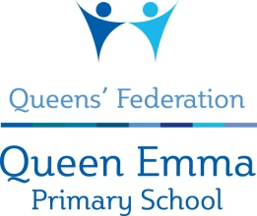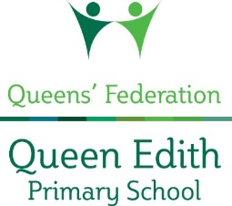

Dear Parent Carer

Thank you for enquiring about volunteering at Queen Edith Primary School. Any time you can offer to support the children’s learning is greatly appreciated.

We believe that our school should be open and welcoming to all who would like to support the children. We want to ensure that volunteers are welcomed and valued as members of the school community. If you are able to commit to volunteering at Queen Edith and help support the children’s learning, please take a look at our Volunteer’s pack. This is available from our website www.queenedithschool.org.uk or from the school office.

At Queen Edith Primary School we have an over-riding duty for the safety of the children in our care. In accordance with ‘Keeping Children Safe in Education’ we ask volunteers to read ‘Keeping Children Safe in Education’, September 2021, Part 1, and ‘What to do if you’re worried a child is being abused’. Volunteers are also required to sign the volunteer agreement and to attend a short workshop about safeguarding procedures in our school. These documents form part of our Volunteer’s pack, detailed above.

There are two types of volunteers who help in school. We have parents who kindly offer to accompany children on a trip or occasionally come into school to help in the classroom. These volunteers are never left alone with groups of children and only come into school infrequently. These volunteers should complete the volunteer agreement and registration form, giving details of two professional referees, but will not need to complete a DBS check. For volunteers who are able to make a regular commitment to helping in school and who may be asked to work frequently with individual children or small groups of children we are required to ask for two references and that a DBS (Disclosure and Barring Service) check is completed.

If you do require a DBS Check please contact the school office. A list of the documentation needed to complete a DBS check forms part of your Volunteer pack. Any checks or references will need to be completed before you begin your volunteering.

Your help and support are hugely welcome and will make a real difference for the children at our school. We shall look forward to receiving your application and welcoming you into our community.

Yours sincerely
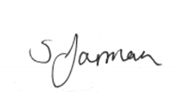
Sarah Jarman
Executive Headteacher

